Business question: How much revenue does the e-commerce business generate, and how many orders and items does it sell?
01_sales_overview.sql:-
-- 1. Overall sales performance
SELECT
COUNT(DISTINCT o.order_id) AS total_orders,
COUNT(*) AS total_order_items,
ROUND(SUM(oi.price), 2) AS item_sales_revenue,
ROUND(SUM(oi.freight_value), 2) AS total_freight,
ROUND(AVG(oi.price), 2) AS average_item_price
FROM olist_orders o
JOIN olist_order_items oi
ON o.order_id = oi.order_id
WHERE o.order_status = 'delivered';



Business question: Which months perform best, and is revenue growing or declining?
02_monthly_revenue.sql:-

WITH monthly_sales AS (
SELECT
DATE_TRUNC(
'month',
o.order_purchase_timestamp
)::DATE AS sales_month,
SUM(oi.price) AS revenue,
COUNT(DISTINCT o.order_id) AS total_orders
FROM olist_orders o
JOIN olist_order_items oi
ON o.order_id = oi.order_id
WHERE o.order_status = 'delivered'
GROUP BY 1
),
monthly_growth AS (
SELECT
sales_month,
revenue,
total_orders,
LAG(revenue) OVER (
ORDER BY sales_month
) AS previous_month_revenue
FROM monthly_sales
)
SELECT
sales_month,
ROUND(revenue, 2) AS revenue,
total_orders,
ROUND(
revenue - previous_month_revenue, 2
) AS revenue_change,
ROUND(
100.0 * (revenue - previous_month_revenue)
/ NULLIF(previous_month_revenue, 0),
2
) AS mom_growth_percent
FROM monthly_growth
ORDER BY sales_month;

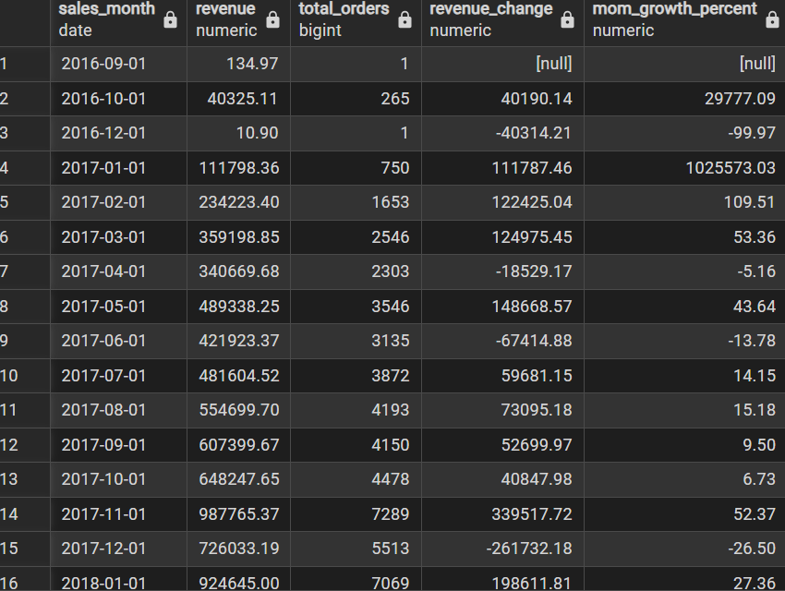
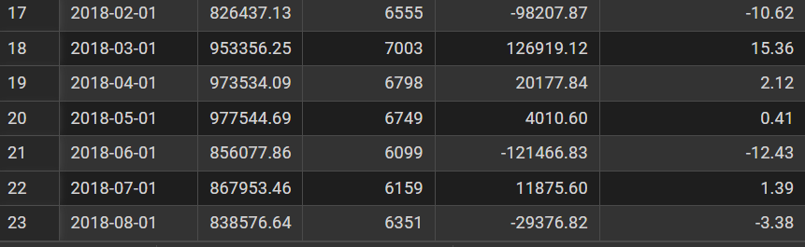

Business questions: How many unique customers do we have? How often do they purchase? What is the average order value?
03_customer_analysis.sql:-
A. Customer and order summary
WITH customer_orders AS (
SELECT
c.customer_unique_id,
o.order_id,
SUM(oi.price) AS order_value
FROM olist_customers c
JOIN olist_orders o
ON c.customer_id = o.customer_id
JOIN olist_order_items oi
ON o.order_id = oi.order_id
WHERE o.order_status = 'delivered'
GROUP BY c.customer_unique_id, o.order_id
),
customer_summary AS (
SELECT
customer_unique_id,
COUNT(*) AS order_count,
SUM(order_value) AS customer_revenue
FROM customer_orders
GROUP BY customer_unique_id
)
SELECT
(SELECT COUNT(*) FROM customer_summary)
AS unique_customers,
(SELECT COUNT(*) FROM customer_orders)
AS delivered_orders,
ROUND(
(SELECT AVG(order_value) FROM customer_orders), 2
) AS average_order_value,
ROUND(AVG(order_count), 2)
AS average_orders_per_customer,
ROUND(AVG(customer_revenue), 2)
AS average_revenue_per_customer
FROM customer_summary;

B. New vs. returning customers
WITH customer_orders AS (
SELECT
c.customer_unique_id,
COUNT(DISTINCT o.order_id) AS order_count
FROM olist_customers c
JOIN olist_orders o
ON c.customer_id = o.customer_id
WHERE o.order_status = 'delivered'
GROUP BY c.customer_unique_id
)
SELECT
CASE
WHEN order_count = 1 THEN 'One-time customer'
ELSE 'Returning customer'
END AS customer_type,
COUNT(*) AS customers
FROM customer_orders
GROUP BY customer_type
ORDER BY customers DESC;

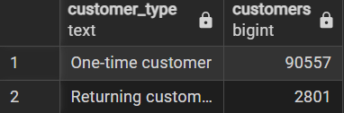

Business questions: Which categories generate the most revenue? Which products sell best?
04_product_analysis.sql:-
A. Revenue by product category
SELECT
COALESCE(
t.product_category_name_english,
p.product_category_name,
'Unknown'
) AS product_category,
COUNT(DISTINCT oi.order_id) AS orders,
COUNT(*) AS item_rows,
ROUND(SUM(oi.price::NUMERIC), 2) AS revenue
FROM olist_order_items oi
JOIN olist_orders o
ON oi.order_id = o.order_id
JOIN olist_products p
ON oi.product_id = p.product_id
LEFT JOIN product_category_translation t
ON p.product_category_name = t.product_category_name
WHERE o.order_status = 'delivered'
GROUP BY 1
ORDER BY revenue DESC
LIMIT 15;

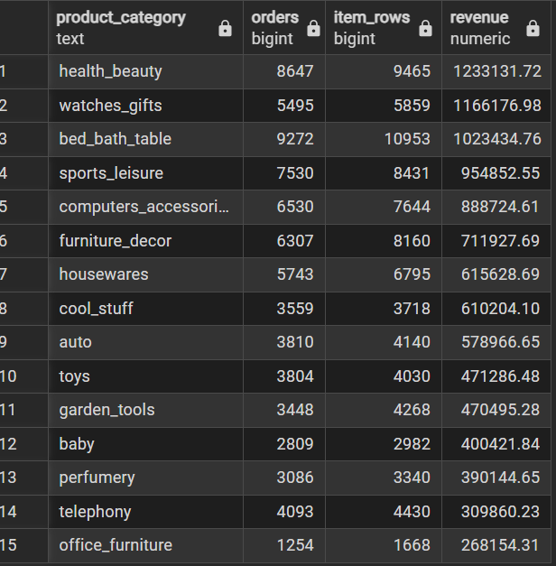

B. Top-selling products

SELECT
oi.product_id,
COUNT(DISTINCT oi.order_id) AS orders,
COUNT(*) AS item_rows,
ROUND(SUM(oi.price), 2) AS revenue
FROM olist_order_items oi
JOIN olist_orders o
ON oi.order_id = o.order_id
WHERE o.order_status = 'delivered'
GROUP BY oi.product_id
ORDER BY revenue DESC
LIMIT 10;

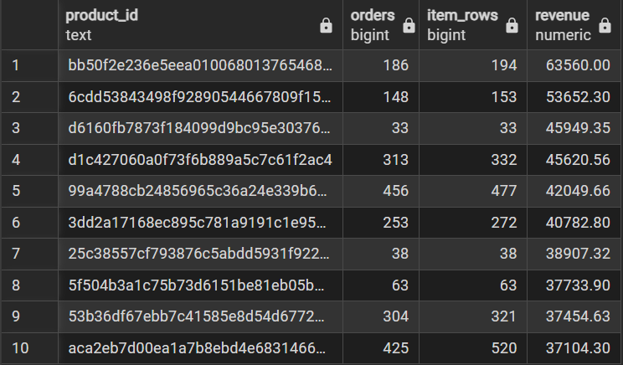

Business question: Which customer states generate the most revenue?
05_geographic_analysis.sql:-
SELECT
c.customer_state,
COUNT(DISTINCT c.customer_unique_id)
AS unique_customers,
COUNT(DISTINCT o.order_id) AS delivered_orders,
ROUND(SUM(oi.price), 2) AS revenue
FROM olist_customers c
JOIN olist_orders o
ON c.customer_id = o.customer_id
JOIN olist_order_items oi
ON o.order_id = oi.order_id
WHERE o.order_status = 'delivered'
GROUP BY c.customer_state
ORDER BY revenue DESC;

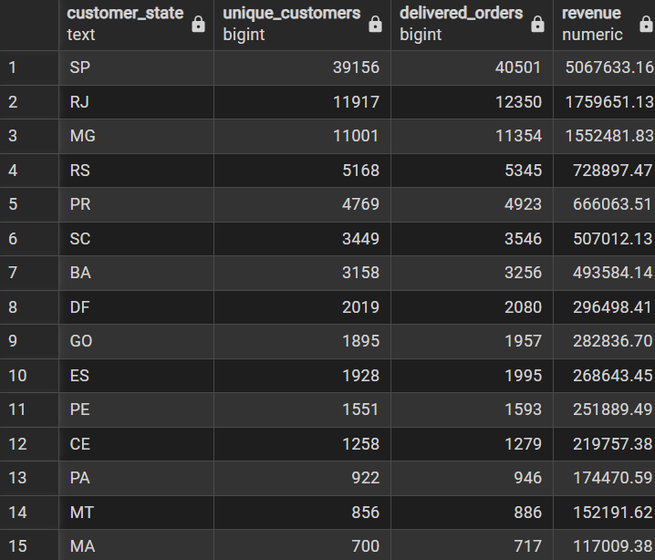
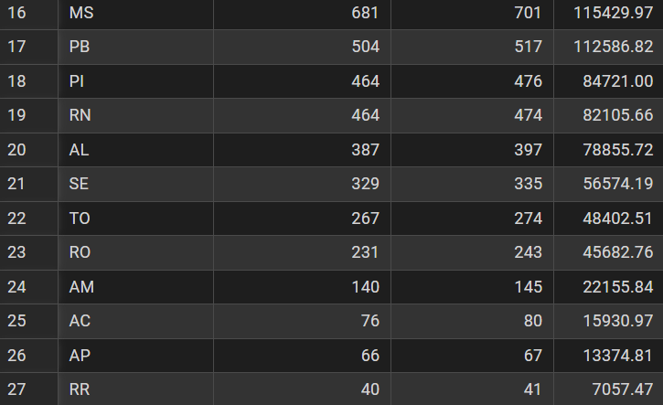

Recency: How recently did a customer purchase?
Frequency: How many delivered orders did they place?
Monetary: How much item revenue did they generate?
06_rfm_analysis.sql:-
WITH customer_metrics AS (
SELECT
c.customer_unique_id,
MAX(o.order_purchase_timestamp)::DATE
AS last_purchase_date,
COUNT(DISTINCT o.order_id) AS frequency,
SUM(oi.price) AS monetary
FROM olist_customers c
JOIN olist_orders o
ON c.customer_id = o.customer_id
JOIN olist_order_items oi
ON o.order_id = oi.order_id
WHERE o.order_status = 'delivered'
GROUP BY c.customer_unique_id
),
rfm_scores AS (
SELECT
*,
NTILE(5) OVER (
ORDER BY last_purchase_date ASC
) AS recency_score,
NTILE(5) OVER (
ORDER BY frequency
) AS frequency_score,
NTILE(5) OVER (
ORDER BY monetary
) AS monetary_score
FROM customer_metrics
)
SELECT
*,
CASE
WHEN recency_score >= 4
AND frequency_score >= 4
AND monetary_score >= 4
THEN 'Champions'
WHEN frequency_score >= 3
AND recency_score >= 3
THEN 'Loyal Customers'
WHEN recency_score >= 4
AND frequency_score <= 2
THEN 'New / Potential Customers'
WHEN recency_score <= 2
AND frequency_score >= 3
THEN 'At-Risk Loyal Customers'
WHEN recency_score <= 2
AND frequency_score <= 2
THEN 'Lost / Inactive Customers'
ELSE 'Needs Attention'
END AS customer_segment
FROM rfm_scores;

